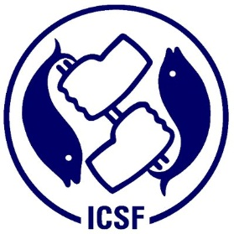 | 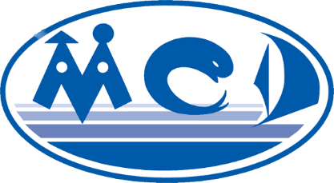

VIE 001

ACTIVITY REPORT

Awareness-raising workshop in the central coastal region for local government and small-scale fishing communities on co- management and combating IUU fishing in light of the Amended Fisheries Law of Viet Nam

28th September 2018
Quy Nhon City, Binh Dinh Province

1. Background:
Between 2014 and 2018, Vietnam seized over 917 illegal fishing vessels in the waters bordering China, ASEAN and non-ASEAN countries. China, Indonesia and Cambodia are the three countries with the highest rate of detention of fishing vessels in Vietnam. Actions against IUU fishing are supported by a range of international institutions and instruments, including the 1982 United Nations Convention on the Law of the Sea (UNCLOS), the 1995 UN Fish Stocks Agreement (UNFSA), and the 1995 FAO Code of Conduct for Responsible Fisheries (CCRF). Vietnamese law also provides specific provisions on IUU fishing practices under the revised Fisheries Law of 2017, adopted by the National Assembly at its Fourth Session on November 21st, 2017.
On 28 September 2018, the Center for Marinelife Conservation and Community Development (MCD) and the Department of Agriculture and Rural Development of Binh Dinh Province jointly organized a “Policy Consultation, Communication and Sharing Workshop on the Mitigation of Illegal Fishing, Co-management and Protection of Fisheries Resources in the Central Coast”. The workshop was supported by the International Collective in Support of Fishworkers (ICSF) under the FAO-funded project on the implementation of the SSF Guidelines in nine countries, including Vietnam. The Fisheries Law of 2017, an important milestone in institutionalizing co-management, formally defined co-management in Article 10. The efforts of D-Fish and other concerned parties such as MCD have included initiatives such as issuing regulations for the recognition and assignment of management rights to community organizations.
According to D-Fish, IUU fishing is prohibited, but such activities are still prevalent. Illegal harvest must be prevented to reduce the decline of resources, allow for the advancement of sustainable development, and protect the rights and interests of the community. Co-management is a strategic solution for combating IUU fishing

- Objectives:
The objectives of the workshop were to promote communication and awareness amongst stakeholders of illegal, unreported and unregulated (IUU)-related policy and co-management practices to reduce illegal fishing, and co-management of the living resources of the reef ecosystems.
- Methods:
The workshop creates a platform on IUU/co-management of small scale fisheries through the key presentations, dialogues and further discussion on the opportunism and challenges, it has engaged a number of fishermen groups and key stakeholders in the central coasts. It has some following sections: (1) Presentations on the key policies and actions plans on IUU/co-management of high level policy makers/D-fish (2) Practical sharing experiences by the central coastal provinces including Binh Dinh, Thua Thien Hue, Quang Nam and Quang Ngai provinces (3) Open discussion on the challenges, opportunities and recommendations/actions by a participatory engagement.
The main contents of the workshop included: (i) an overview of the central regions and local policies, programming and current action plan; (ii) discussion about the need for co-management awareness, minimization of illegal practices, application of successful practical lessons in the coastal region of Central Vietnam; (iii) link policymakers, regulatory agencies, and fisher community organizations in activities to strengthen co-
Participants:
The workshop was attended by 47 representatives (39 male, 8 female) from the D-Fish, the Binh Dinh Department of Agriculture and Rural Development, the Departments of Fisheries in the central provinces of Thua Thien Hue, Phu Yen and Binh Dinh, the Binh Dinh Fisheries Association, the Quy Nhon City People’s Committee and commune council, community organizations of four Locally Managed Marine Area (LMMA) communes in Quy Nhon and representatives of fishing groups in the central areas of Cu Lao Cham and the Ly Son marine protected area (MPA).

- Key results and findings:
The main contents of the workshop included: (i) an overview of the central regions and local policies, programming and current action plan; (ii) discussion about the need for co-management awareness, minimization of illegal practices, application of successful practical lessons in the coastal region of Central Vietnam; (iii) link policymakers, regulatory agencies, and fisher community organizations in activities to strengthen co-management, exploitation and protection of fisheries resources in order to minimize illegal practises.
The Binh Dinh province has 6,245 fishing vessels with a total capacity of 1,786,631 CV, 286 CV / 01 average. (From 20 vessels: 218%), from 20-90cv: 1,238 ships (19.8%), from 90 CVs to 3,662 ships (58.5%) The total number of employees engaged in fishing activities is 44,350 (offshore fishing is 29,512 people, coastal fishing is 14,838 people), of which 2,312 ships (36.9% Trades: 454 (7.3%), trawl net: 486 (7.8%) Other: 1,448 ships (23%). Seafood catch: in 2017 reached 223,000 tons, of which tuna was 47,000 tons; Atlantic tuna (big eyed, yellowfin tuna): 9,700 tones; Ink: 22,000 tons; Shrimp: 1,200 tons; Marine fish of all kinds: 143,100 tons.
The status of fishing vessels operating without fishing permits, expired or expired fishing permits accounts for 46% fishing vessels in the whole province. The number of fishing boats is quite large (<20 cv: 1,358 ships (accounting for 21.7% of the total number of registered boats), affecting the coastal fishery resources).
The operation of fishing vessels in areas not regulated for operation, often on a complicated basis (especially trawl net fishing vessels, heavy duty fishing vessels ...), very much affect coastal fishery resources. Some forms of catching these marine species are prohibited such as, using explosives, electric pulse, circus machine, cage netting, and so forth. To overcome these practises, the province has reviewed the statistics of fishing vessels which are either not registered, registered and/or licensed with them. Initial results were 1,392 / 2,891 ship owners, accounting for 48.2% of the information (including 1,168 listed fishing vessels, and 224 unregistered fishing vessels (not included in the list).
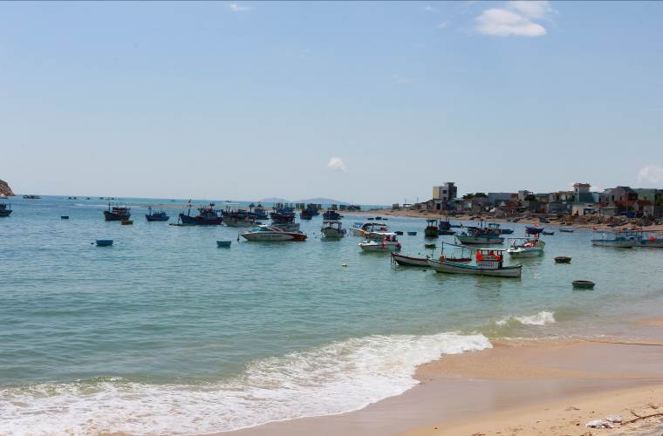

Smal scale fisheries in Nhon Hai commune, Quy Nhon City, Binh Dinh province

Binh Dinh will continue to carry out its plan - to review the number of ships that have not registered for registration and licensing. Quarterly, the fisheries stations will record the number of vessels in the area to unify data between local and grassroots statistical offices. Strengthening the coordination between the authorities responsible for handling fishing vessels is another significantly important activity. Promote through various forms of advertisement and raise awareness to people about the law. Training to improve the management capacity of vessels for inter-commune staffs through sector programming. Binh Dinh as well as implementing various measures to reduce illegal fishing in offshore areas, is working to apply these measures in coastal areas through the various activities listed below:
- Trafficking is practically unlicensed, and it is a severe form of depletion of fishery resources, so strict controls on registration and review are needed to ensure strict control.
- Skidding has been put on the list of IUU banned activities in Binh Dinh province and is being processed step by step.
- Unlicensed diving due to occupational health, is less effective than scuba diving because it takes less time per hour to dive.

Participants in the workshop
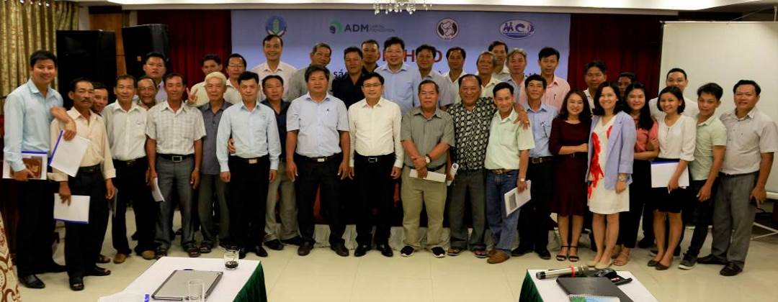

5. Opportunities:
- To build a national database on management of fishing vessel registration and synchronous fishing permits at central and local levels.
- To promote bilateral co-operation to prevent IUU fishing and illegal trade through establishment of hotlines, and through dialogue with other countries in the region for the sustainable use of marine resources.
- To improve law enforcement capacity, requiring fishing vessels of length 15m or more to install cruise control equipment.
- To strengthen direction, management and effectiveness in management of fisheries and IUU fishing.
6. Challenges:
- There are many shortcomings in the policy, organizational framework and monitoring of small-scale fisheries.
- IUU will continue to persist if further action is not taken to provide alternative livelihoods to coastal communities
- Uneven results throughout various communities has resulted in IUU activity occurring in communities which are successful at performing conservation activities, therefore resulting in healthier ecosystems. Further pressures are applied as fishermen flock to an area of high species richness.
- Incentives and punishments do not effectively enforce desired behavior resulting in increased IUU activity.

7. Recommendations and Follow-up Actions:

Illegal exploitation is a matter of concern to governments and local authorities. Fisheries Law Amendment 2017 introduced the IUU issue into Section 6, Article 7 of the Fisheries Law: "Illegal, unreported, unregulated fishing (hereinafter referred to as illegal fishing) and the buying, selling, transporting, storing, preliminarily processing and processing aquatic products from illegal fishing, fishery contain impurities for trade fraud purposes". Article 10 of the Fisheries Law 2017 on the co-management of fisheries resources, regulations on participation conditions of the community, recognizes the district has the right to recognize and assign the right to manage fisheries resources in the area under the management. The co-management team is responsible for: (i) Properly implementing the contents stated in the accreditation decision and delegation of management. (ii) comply with the law on fishery activities; Inspection and examination by competent state agencies according to the provisions of law; (iii) Coordinating with relevant authorities to patrol, inspect, investigate, prevent and deal with violations in the assigned area; (iv) Reporting to competent state agencies on the operation of community organizations according to regulations.
A number of recommendations for mitigation of IUU and strengthening of co-management in fisheries resources protection in Viet Nam:
(1) Raise awareness about IUU reduction:
  - Use of information and communication systems for change of perception (mass media and target groups) to comply with laws and regulations on sustainable exploitation;
  - Organize media campaigns and advocacy through coordination between government and people, social organizations (including Fisheries Association);
  - Develop and implement communication programs to reduce IUU illegal fishing, at the provincial / district / commune level in association with the central action plans.
(2) Support livelihood development and employment for fishermen groups:
- Fishery resources have been significantly reduced due to unsustainable capture fisheries. Livelihoods and alternative income for fishermen need high priority;
- Technical training for fisheries groups on sustainable harvesting techniques, postharvest preservation (coordination of experts);
- Developing coastal tourism, vocational training for youth, reducing pressure on exploitation of natural resources in association with ecosystem preservation and service development;
- Access to necessary resources for people (including skills, information technology, markets) is essential to ensure livelihoods.
(3) Support the implementation of co-management regulations, capacity building of community groups in sustainable fishery practices
- Capacity building / strengthening of community organizations involved in co-management, training support, strengthening of facilitators';
- Support for management planning, exploitation and protection of sustainable practises and management of community organizations;
- Promote coordination at the central and local levels, by creating mechanisms for monitoring and evaluating and effectively enforcing co-management regulations in sustainable capture fisheries.
(4) Strengthen surveillance system, traceability and product certification in accordance with regulations
- Strengthening the capacity of the fisher groups to improve responsible fishing practices, use of fishing gear and legal fishing grounds;
- Strengthen cooperation with the business sector to improve traceability, improve recording / reporting practices in fishing ports and fishing areas, and comply with market regulations and requirements;
- Technical assistance to improve local and national monitoring and reporting systems.

