network activities group
Co-management ToT Training
Training Report
NAG
6/18/2019
MYR 005

Contents
Summary of the Training 0
Background 0
Training Objectives 0
Training Agenda 0
Opening Speech by U Hla Mying (Project Coordinator, NAG) 1
Historical Mapping (Group Discussion) 1
Basic facts that decreased the fishery resources (Group Discussion) 1
Group discussion on the impact of decreased fishery resources 2
Mapping the fishery co-management (Group Discussion) 3
Stakeholder Mapping (Group Discussion) 3
Seasonal fish catch (group discussion) 4
Training Second Day 4

Summary of the Training
In order to ensure effective community participation in the management process, ICSF project cooperated with ICAWR project team in facilitating FDAs and ARFNs to undertake a participatory review of their existing co-management by organizing training which had a strong participation from the fisheries representatives targeted co-management zones. The training was organized at KMSS Center, Pathein Township on 16th, 17th and 18th June 2019 for three days including one day for field visit with a participation of 32 numbers of participants (Male 27, Female 5) largely from the FDAs and cluster leaders of co-management zone. At the end of the training the ToT received participants developed the trip plan and agenda for mobile awareness raising program to their respected areas in collaboration with Capacity Building Coordinators.

Background
The strategic partnership agreement (SPA) reached with LIFT aimed to support the Network Activities Group (NAG) to advance its role as the leading fisheries governance organization operating in Myanmar, and to strengthen its influence in Ayeyarwaddy Region. With the funds provided under the SPA, NAG planned to advocate for and raise the voice of poorer fisher households in legislation and policy discussions so that changes in fisheries governance benefited the people who depended most on these resources. The partnership’s focus was on improving the lives of the poorest and most vulnerable households in fishing communities, through improving their access to fisheries resources and strengthening their participation in co-management. Advocacy for fisheries legislation aimed to provide more inclusive laws and policies favouring poorer fisher families.
Co-management awareness training was conducted in Pathein, with the participation of the members of FDA from Dadaye, Mawlamyaingkyun, Danuphyu, Labutta, Thabaung, and Pantanaw and the members of cluster level fisher groups. It was led by the project staff and NAG Yangon staff, where total 32 participants with male 27 and female 5 participants attended.

Training Objectives
- To be able to understand the co-management system by the stakeholders
- To be practical in planning the fishery co-management plan

Training Agenda
- Opening speech
- Explaining the training objectives
- Fishery historical mapping for each area
- Illustrating the facts that decreased the fishery resources
- Illustrating the effects on the community due to the decreased fishery resources
- Resource mapping for each respective fishery co-management areas
- Seasonal calendar for fishery
- Stakeholder mapping
- Planning for fishery co-management awareness and activity plan for each area
- Field implementation in the project areas

Opening Speech by U Hla Mying (Project Coordinator, NAG)
U Hla Myint, Project Coordinator of NAG addressed an opening speech at the training, explaining that the project is strongly focusing on the emergence of successful co-management system. In its regard, the collaboration and coordination of the stakeholders are strongly required. He continued explaining that the participants are the fishery group leaders in the community which mean that they have to lead the fishery development in their own when the project phases out at some point. Therefore, he suggested the participants to share they knowledge gained from the training back in their communities.

Historical Mapping (Group Discussion)
Representatives from each co-management pilot zones discussed their challenges throughout the history and presented.
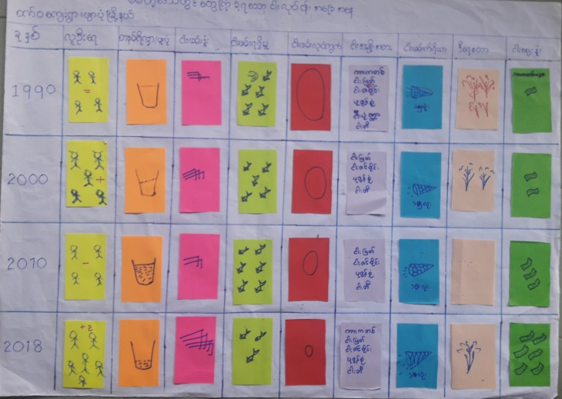

Basic facts that decreased the fishery resources (Group Discussion)
Group discussions were conducted on the topic of the basic facts that decreased the fishery resources in these 6 piloted areas. The results from the discussions were presented by each group

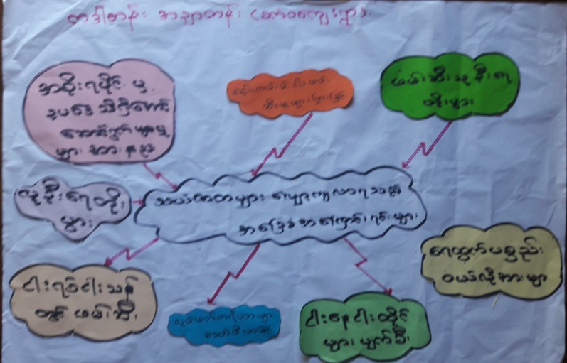

Group discussion on the impact of decreased fishery resources
Representatives from each co-management zone had discussed in a group about how the fishery resources declining impact their health, social, economic and community development. Then they presented their discussion points.
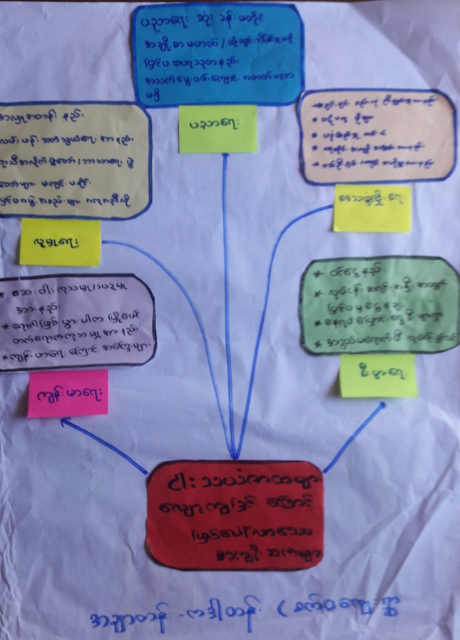

Mapping the fishery co-management (Group Discussion)
Members of committees from each co-management area had discussed and mapped out their co-management areas.

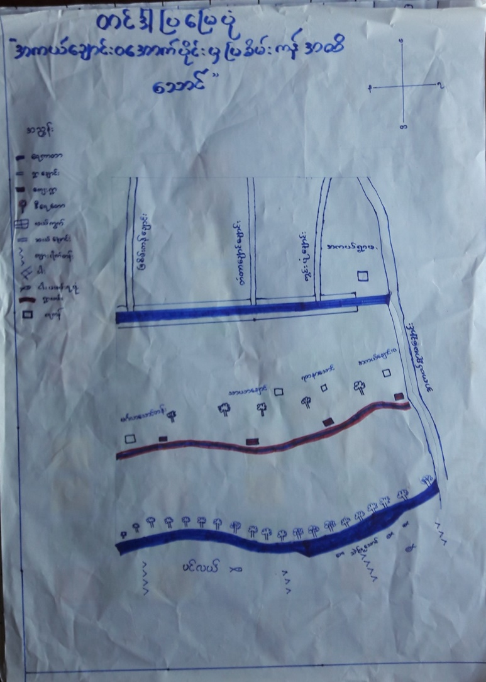

Stakeholder Mapping (Group Discussion)
Participants from each co-management pilot zone had discussed and tried to draw the stakeholder mapping within their managed areas. Then they presented their stakeholder map.
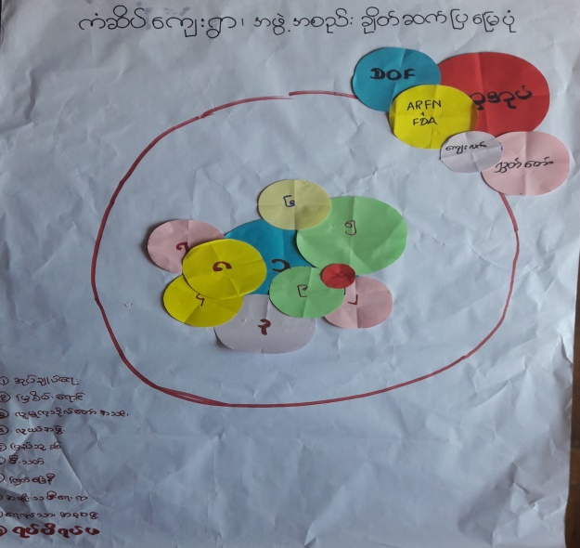

Seasonal fish catch (group discussion)
Participants from each fishing zone discussed in the group on their fish catch seasonally and presented it.
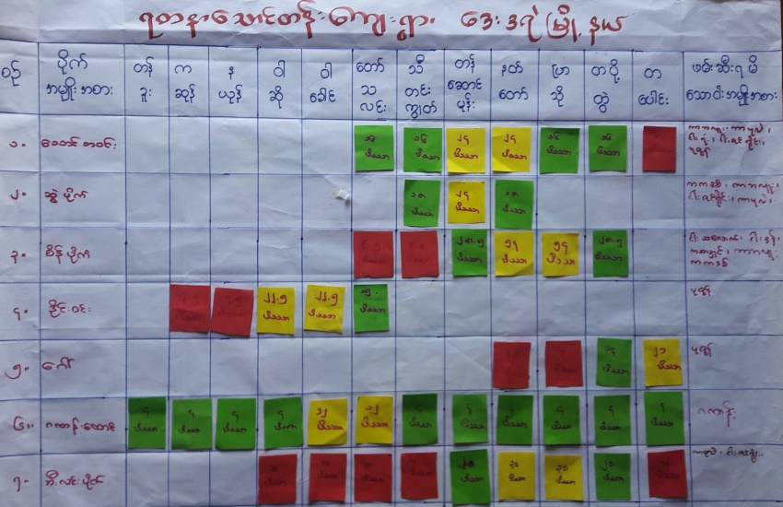

Training Second Day
In the second day of the training, project staff led the discussion on the following topics that relate to fishery co-management;
- Discussion on the challenges being faced by the fishers
- Discussion on the challenges being faced by the departments
- Discussion on the definitions of fishery
- Discussion on how co-management could be effectively done
- 7 steps in implementing the co-management system
- Advantages of co-management
- Things that must to know to have a successful co-management system
- 10 practical facts in fishery co-management
On the final day of the training, participants got the chance to have a field trip to A Kyaw village and led the discussion with the fishers about the co-management system and its principles in detail.

Annex (1) – Training’s Participants List
Sr | District | Township | Postal Address | Village | Name | Sex
1 | Labutta | Labutta | 10121 | Ah Yar Daw | U Mya Aung | Male
2 |  | Labutta | 10121 | Ah Yar Daw | U Myo Naing | Male
3 |  | Labutta | 10121 | Ah Yar Daw | U Lin Tun | Male
4 |  | Labutta | 10121 | Ah Yar Daw | U San Min | Male
5 |  | Mawlamyinegyun | 10221 | Myin Ka Kone | U San Oo | Male
6 |  | Mawlamyinegyun | 10221 | Myin Ka Kone | U Maung Maung Kyaw | Male
7 |  | Mawlamyinegyun | 10221 | Aye Yar Chaung | U Kyaw Sein | Male
8 |  | Mawlamyinegyun | 10221 | Kyon La Tar | Daw Htet Htet Aung | Female
9 | Maubin | Danubyu | 10151 | Ah Kyaw | U Than Oo | Male
10 |  | Danubyu | 10151 | Ah Kyaw | U Aung Kyaw Myint | Male
11 |  | Danubyu | 10151 | Ah Kyaw | U Aye Thein | Male
12 |  | Danubyu | 10151 | Kyon Pain | U Mya Htwe | Male
13 |  | Pantanaw | 10171 | Mwayt Pin | U Thein Lwin | Male
14 |  | Pantanaw | 10171 | Min Ta Su | U Myo Myint Than | Male
15 |  | Pantanaw | 10171 | Min Ta Su | U Khin Maung San | Male
16 |  | Pantanaw | 10171 | Min Ta Su | U San Tint | Male
17 | Pahthein | Thabaung | 10111 | Kyon Ta Dun | U Kyi Myint | Male
18 |  | Thabaung | 10111 | Kyon Ta Dun | U Aung Thu | Male
19 |  | Thabaung | 10111 | Kyon Ta Dun | U Khin Tun | Male
20 |  | Thabaung | 10111 | Kyon Ta Dun | U Lin Naing Tun | Male
21 | Pyapon | Dedaye | 10261 | Thagyar Hin Ohe | U Min Nge | Male
22 |  | Dedaye | 10261 | Nat Pin Sain | U Kyaw Aung | Male
23 |  | Dedaye | 10261 | Kan Seik | Daw San San Ye | Female

Participants from Project Team
Sr | Township | Postal Address | Position | Name | Sex
1 | Pathein | 10011 | Capacity Building Coordinator | U Soe Moe Aung | Female
2 | Pathein | 10011 | Capacity Building Coordinator | U Min Zaw Oo | Male
3 | Pathein | 10011 | Capacity Building Coordinator | Daw Thida Soe | Male
4 | Pathein | 10011 | Research Coordinator | Daw Wint War Lwin | Female
5 | Pathein | 10011 | Communication Officer | U Zaw Naing Win | Male
6 | Pathein | 10011 | Internship | Daw Yi Yi New | Male
7 | Pathein | 10011 | M&E Officer | U David Tin Mg Aye | Male
8 | Yangon | 11431 | M&E Officer | U Myo Zaw Aung | Male
9 | Yangon | 11431 | Program Associate | U Nyi Nyi Zaw | Male

Annex (2) – Training’s Photos
